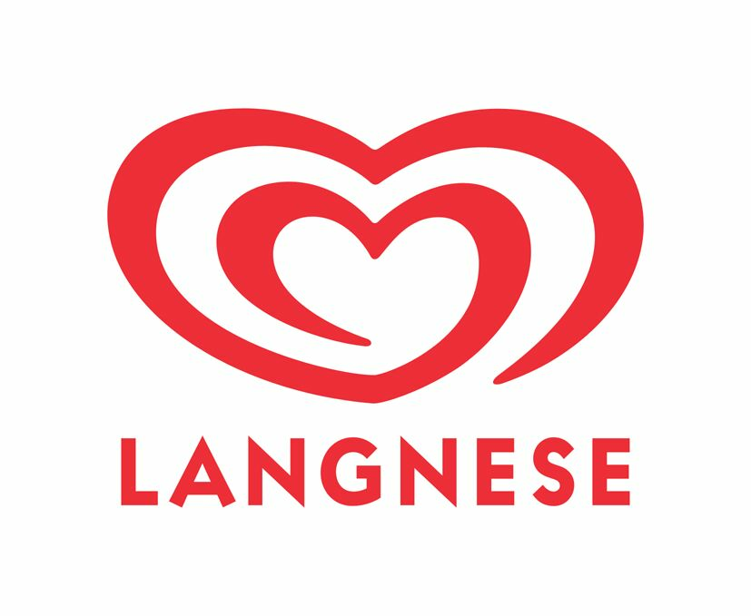

**SU HEPPENHEIM**

Hygiene regulations for external companies

The general hygiene regulations are based on laws and the company's own

Quality standards. After that we are obligated to maintain cleanliness, order and hygiene.

in our business. The regulations supplement in agreement with the

Works Council the works regulations of the plant from 01.03.2006.

1. Only persons wearing clean working clothes intended for work in the production area are permitted to enter the hygiene area. (The hygiene areas are marked by hygiene boards). Buttons and zippers must be closed, sleeves and trouser legs must not be pushed up or rolled up, arms and legs must be covered.
2. Observe the dress code. It is not allowed to wear scarves, neckerchiefs or the like in hygienic areas. It is not permitted to wear private clothing that extends beyond work clothes. This also applies to collars and sleeves.

3. The necessary work protective equipment, hearing protection, protective goggles, etc. must be used.

4. Only special ballpoint pens or Edding may be used in the hygiene areas. Other pens, such as highlighters, may only be used

in exceptional cases.

5 The hair must be worn completely under the headgear. Beard wearers must wear beard pads when working on open products

or in the immediate vicinity of open products.

6. Hands must be thoroughly washed and disinfected before entering the hygiene area. Hands must be kept clean and –

If necessary - washed and disinfected occasionally (e.g. after contact with waste, floors, unclean objects or touching hair).

7. No jewellery may be worn when working in the hygiene area, e.g. wedding rings, chains, watches, open piercing.

8. Do not cough or sneeze on food or packaging materials, do not spit them out.

9. Only objects may be used for sitting which are intended as a seat. Packaging materials, all types of buckets and tables are

not seats.

10. Fingernails are to be kept clean and short, nail polish /-gel or similar as well as artificial fingernails are prohibited.

11. Disposable gloves must be worn when in contact with open goods. These must be changed if soiled.

12. Wounds on uncovered body parts, even small scratches, must be covered waterproof. Special patches (blue metallized) and

suitable disposable gloves should be used. Before starting the work, your own household plasters must be replaced by the

company's own patches.

13. The workplace must be kept clean, work equipment must be cleaned if necessary, dirt must be removed and waste disposed

of.

14. Eating and drinking in the production area and in the cloakrooms is not allowed, this includes in particular chewing gum

and lollipops of sweets and the like in the hygiene areas

15. It is forbidden to take medication in the production area.

16. Smoking is prohibited on the factory premises, only permitted in front of the factory gate at the marked outdoor smoking area.

17. The introduction of wood into the production area is not permitted.

18. The introduction of glass of any kind into the factory is not permitted. Glass finds on the factory premises must be reported to

the client without delay.

19. Persons who work (even at short notice) in the production area may not suffer from communicable diseases in accordance

with Section 43 of the Infection Protection Act. This applies, for example, in particular to hepatitis (A and E) and diarrhoea,

which last longer than one day, are accompanied by fever and two aqueous bowel ducts.

20. Only the marked toilets "Toilet for non-operating" may be used.

21. Doors and gates to the hygiene areas must be kept closed.



**SU HEPPENHEIM**

Additional clothing rules

Due to the requirements for product safety and hygiene within

SU Heppenheim applies to all those present in the production areas

employees following the following clothing rules:

* the general appearance of the employee must be **neat and clean**
* the clothing must be free of **foreign particles**
* as also applies to the main hair: **hair** must be covered by the work clothes
* the work clothing used must be made of **lint-resistant** and dirt-repellent material. If this requirement is not met with regard to the shirt, an appropriate jacket must be worn. For the purposes of this regulation, work clothing is work trousers, work shirt and work jacket.
* there must be **no outer pockets** on the work clothing **above the hip**, if they do, they must be sewn or empty
* if the **clothing** has been **heavily soiled** during work, i.e. dirt particles or other soiling may fall off or be released from the clothing and the employee enters our specially marked hygienic areas, for which work clothing is prescribed, **the clothing must also be changed during the day if necessary**.
* for every stay within the hygiene areas, wearing **safety shoes and goggles** is mandatory

**SU Heppenheim can provide a visitor's overall, goggles and safety shoes for a short stay in production.**

**Noted:**

|  |  |  |  |  |
| --- | --- | --- | --- | --- |
| NAME | FIRSTNAME | COMPANY | DATE | SIGNATURE |
|  |  |  |  |  |

The hygiene rules and clothing rules in production areas are communicated to each new contractor when the order is placed. For all who provide services on a regular and recurring basis, a one-time application of the rules and regulations is sufficient annually. The document must be returned signed by the Contractor with the order confirmation. By signing, the contractor confirms that it informs its employees of these regulations and rules and ensures that they are complied with.